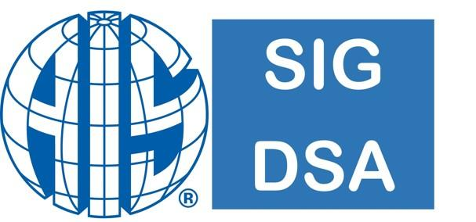

www.sigdsa.org

Association of Information Systems (AIS)
Special Interest Group on Decision Support and Analytics (SIGDSA)
2025 SIGDSA Symposium on
Analytics for Seamless Digital Integration in the Age of AI
December 13 and 14, 2025
Nashville, Tennessee
https://preicis.sigdsa.org/

Symposium Exhibitor/Sponsorship Form

Name of Organization ______________________________________________
Representative Attending Meeting ______________________________________________
Billing Address ______________________________________________
______________________________________________
Telephone/Fax ______________________________________________
E-mail ______________________________________________
METHOD OF PARTICIPATION |  |  | FEE |  | AMOUNT PAID
Exhibit Space |  | One 6 Foot Table (One Meeting  Registration Included) | $650 |  | $ ____________
 |  | Additional Meeting Registrations (each) | $100 |  | $ ____________
Coffee Break |  | Primary Sponsor | $450 |  | $ ____________
 |  | Co-Sponsor | $300 |  | $ ____________
Student Paper Awards |  | Primary Sponsor | $1,000 |  | $ ____________
 |  | Co-Sponsor | $500 |  | $ ____________
Symposium Reception |  | Primary Sponsor | $2,000 |  | $ ____________
 |  | Co-Sponsor | $1,000 |  | $ ____________
Symposium Lunch |  | Primary Sponsor | $2,000 |  | $ ____________
 |  | Co-Sponsor | $1,000 |  | $ ____________
General Sponsorship |  |  | $500 |  | $ ____________
Other - If you would like to sponsor the symposium at a different level, please indicate your desired level of sponsorship, along with any specific requests:
___________________________________________________________ $ ______ |  |  |  |  | $ ____________
TOTAL |  |  |  |  | $ ____________

Gold Sponsor - Symposium Lunch or Reception sponsorship ($2500 or more) includes the following benefits:
• A table in the symposium area
• Two full registrations or 3 student registrations for attending the symposium including official meals
• Opportunity to host panel or workshop
• Organization logo on the front cover of symposium program*
• Organization logo on symposium website with hyperlink to the organization site
• Seat at the head table for keynote ceremony
• Listing in the program as sponsor of the keynote session
• Organization name included in all promotional emails
• Full page ad in symposium program*
• Opportunity to participate in two pre-symposium promotional e-mails.
• Opportunity to add bag inserts

Silver Sponsor ($1500 or more) includes the following benefits:
• One full registration + one student registration for attending the symposium including official meals
• Organization literature at an unmanned table in the symposium area
• Organization logo inside the symposium program*
• Organization logo on symposium website with hyperlink to the organization site
• Quarter page ad in symposium program*
• Opportunity to add bag inserts/swags

Bronze Sponsor ($500 or more) includes the following benefits:
• One full registration for attending the symposium including official meals
• Organization logo inside the symposium program*
• Organization logo on symposium website with hyperlink to the organization site
• Opportunity to add bag inserts/swags

Please note: If you do not see an option that fits your needs, please inquire about the ability to customize an option for your organization. We appreciate your support!
*To be sustainable our symposium program will only be digital.

**************Thanks for your support of SIGDSA**************

